

Spring 2026
GIFT School of Engineering and Applied Sciences

SE-317L: Software Project Management

Lab Manual 10
Change Control Log Using Excel

Introduction to the Lab

Software projects rarely stay the same from start to finish. During development, clients may request new features, users may report bugs, or the project team may suggest improvements. If these changes are not managed properly, they can create confusion, increase project cost, delay deadlines, and reduce software quality.

To solve this problem, software companies use a process called Change Control Management. Change control helps teams record, evaluate, approve, and track every requested change in a structured way. One of the most common tools used for this purpose is a Change Control Log, which stores important details such as the requested change, its reason, impact on project cost and schedule, approval status, and responsible persons. In modern software development, managing document versions is also very important. Teams frequently update documents such as SRS, project plans, and design files. Without proper version control, old files may get lost and team members may work on outdated documents. To avoid this issue, developers use GitHub, a cloud-based version control platform that stores project files, tracks document history, and allows collaboration among team members.

The lab is based on the University Examination & Management System (UEMS) project scenario, where students will act as project team members and manage real-world software project changes using industry practices.

Objectives of this Lab
After completing this lab, students will be able to:
- Understand the importance of change control in software project management.
- Create a professional Change Control Log using Excel.
- Record and analyze software change requests properly.
- Identify the impact of changes on project scope, cost, time, and quality.
- Assign priorities and approval status to change requests.
- Use GitHub for storing and managing project documents.
- Track document versions using file versioning and GitHub commit history.
- Apply version control techniques in a real-world software project scenario.
- Improve teamwork and project documentation management skills.
- Understand how uncontrolled changes can lead to project risks and delays.

3-Hour Lab Breakdown
Time | Activity
0–30 min | Concept recap
30–90 min | Guided hands-on task
90–150 min | Independent student work
150–180 min | Evaluation + viva + submission

Introduction to Change Control
In software projects, changes are very common. A team member may ask to add a new feature, fix a bug, or change how the system works. Without a proper system, these changes can cause confusion, delays, or even break the project.
A Change Control Log is a simple record that tracks every change request in the project. It tells us:
- WHO requested the change
- WHAT the change is about
- WHAT impact it will have on the project
- WHETHER it was approved or rejected

Why Do We Need Change Control?
When a software project is running, people keep asking for new features or changes. Without a proper system, this causes:
- Confusion about what has changed and when
- Delays in the project because changes are not planned properly
- Extra costs that were not budgeted
- Broken features because one change affects another part of the software

Part A — Create a Change Control Log in Excel
Column Name | What it Means (Simple Explanation)
Change Request ID | A unique code like CR-001, CR-002 given to each change request so we can track it easily
Date Submitted | The date when the change was first requested (DD-MM-YYYY format)
Submitted By | The name or role of the person who asked for this change (e.g., Exam Controller, IT Dept)
Description of Change | A clear description of exactly what change is being requested in the software
Reason / Justification | Why is this change needed? What problem does it solve?
Impact Analysis | What will happen if we make this change? Will it take more time? Will it affect other parts?
Priority | How urgent is the change? High = must do now, Medium = do soon, Low = can wait
Approval Status | Has the change been Approved, Rejected, or is it still Pending decision?
Approved By & Date | Who approved/rejected it and on what date?

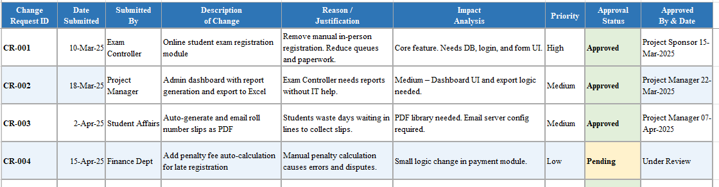

Part B — GitHub Repository for Version Control
GitHub is a website where you can store your project files online. Think of it like Google Drive, but specially designed for software projects. It also remembers every version of your files!

Why do we use GitHub?
- Store project documents safely in the cloud
- Share files easily with your team
- See the history of all changes made to files
- Go back to an older version if something goes wrong

Step-by-Step: Creating Your GitHub Repository

Step | Action | Details
1 | Create Account | Go to github.com → Click 'Sign Up' → Enter email, password, username → Verify email
2 | New Repository | Click '+' top-right → 'New repository' → Name it 'UEMS-Project' → Set Public → Tick 'Add README' → Click 'Create repository'
3 | Upload Files | Inside your repo → Click 'Add file' → 'Upload files' → Drag & drop your documents → Scroll down → Click 'Commit changes'
4 | Create Folders | Click 'Add file' → 'Create new file' → Type 'docs/placeholder.txt' → This creates a 'docs' folder automatically
5 | Version Files | Name files with versions: SRS_v1.0.docx, SRS_v1.1.docx → Upload new version → Old versions stay in commit history
6 | View History | Click on any file → Click 'History' button → See all changes with date, time, and who made them
7 | Edit Online | Click any .md file → Click pencil icon → Edit → Scroll down → 'Commit changes' → Done!

Commands

Configure Git (First Time Only)

Open Git Bash and type:

git config --global user.name "Your Name"

git config --global user.email "your_email@example.com"

Clone Repository to Your Computer

git clone https://github.com/username/UEMS-Project.git

cd UEMS-Project

git status

git add SRS.docx

git commit -m "Added initial project documents"

git push origin main

Updating Files Later

When you edit files later, repeat these commands:

git status

git add .

git commit -m "Updated SRS document"

git push origin main

How to Track Document Versions on GitHub
Version tracking means keeping different versions of the same file so you can see how it changed over time. Here are two easy ways to do it:

Method 1 — File Name Versioning (Easiest for Beginners)
- Upload first version: SRS_v1.0.docx
- When you update it, upload again with new name: SRS_v1.1.docx
- Keep both files — the old one stays, new one is added
- This way you can always see both versions

Method 2 — GitHub Commit History (Automatic)
- Upload the same file name (e.g., SRS.docx)
- Every time you upload a new version, GitHub saves the old one automatically
- Click the file → Click 'History' → See all past versions with dates
- You can even download old versions if needed
Project Scenario
Scenario — University Student Portal
The University of Punjab has over 40,000 students enrolled across 120 departments. Every semester, these students have to visit the university in person to register for exams, pay fees by hand, and collect their roll number slips from the office. The whole process takes weeks and causes long queues, lost paperwork, and many mistakes in student records.
When exam results are ready, the university takes 45 to 60 days to calculate grades manually and inform students. Students have no way to check their results online. They must go to the notice board or wait for a letter in the post. Many students also complain that their marks are entered incorrectly because of human error.
To solve all these problems, the university has hired a software company called TechBridge Solutions to build an online system called the University Examination & Management System (UEMS). This web-based portal will allow students to register for exams online, pay fees using their phones, download their roll number slips instantly, and check their results the moment they are published.
The system will also help teachers enter student marks online, and the system will automatically calculate GPA and CGPA — removing all manual calculation errors. The Examination Controller will be able to generate reports and publish results in just 15 days instead of 60. The total cost of this project is PKR 28,00,000 and it must be completed in 6 months — from March 2025 to August 2025 — so that students can use it from the very next semester.

Lab Task: Create a Change Control Log for the UEMS Project in Excel
- Add at least 10 change requests related to the UEMS project.
- Your change requests must include:
  - Functional changes
  - Security improvements
  - UI/UX improvements
  - Performance issues
  - Emergency bug fixes
- For each change request:
- Estimate whether the change increases:
  - Project cost
  - Development time
  - Testing effort
  - Risk level
- Create 2 conflicting change requests where:
  - Both are marked as High Priority
  - But only one can be implemented due to budget or time limitations
- Create a GITHUB repository named: UEMS-Project
- Repository must contain:
  - README file
  - docs folder
  - reports folder
  - change-control folder
- Upload:
  - SRS_v1.0.docx
  - SRS_v1.1.docx
  - SRS_v2.0.docx
- You must explain:
  - What changed between versions
  - Why versioning is important
Upload the Excel and Word files to GitHub and share your GitHub repository link with me.

